Old Folder Structure

KINGSTON: Programs
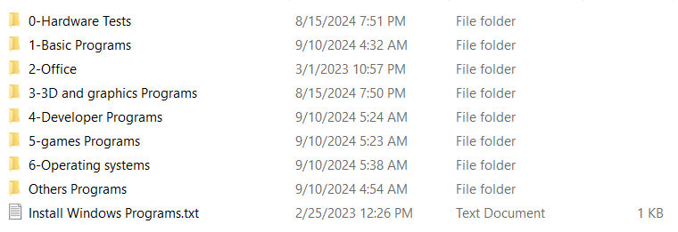
- 0-Hardware Tests
- 1-Basic Programs
- 2-Office
- 3-3D and graphics Programs
- 4-Developer Programs
- 5-games Programs
- 6-Operating systems
- Others Programs
- Install Windows Programs

0-Hardware Tests
It has all hardware tests
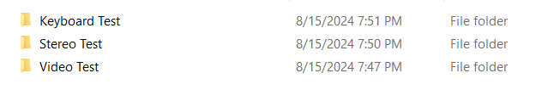

Keyboard Test

Stereo Test

Video Test

1-Basic Programs
It has all Basic Programs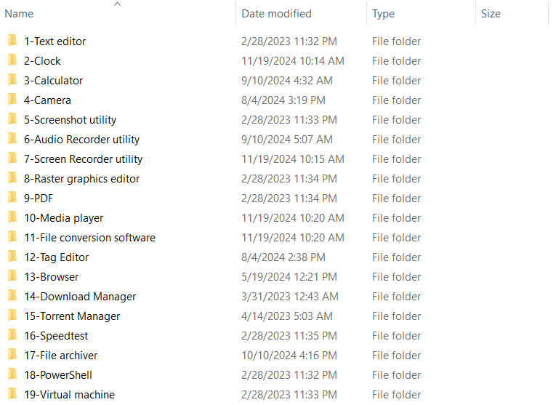
- 1-Text editor
- 2-Clock
- 3-Calculator
- 4-Camera
- 5-Screenshot utility
- 6-Audio Recorder utility
- 7-Screen Recorder utility
- 8-Raster graphics editor
- 9-PDF
- 10-Media player
- 11-File conversion software
- 12-Tag Editor
- 13-Browser
- 14-Download Manager
- 15-Torrent Manager
- 16-Speedtest
- 17-File archiver
- 18-PowerShell
- 19-Virtual machine

1-Text editor
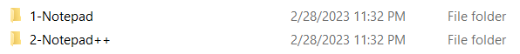

2-Clock


3-Calculator
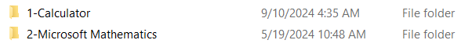

4-Camera


5-Screenshot utility
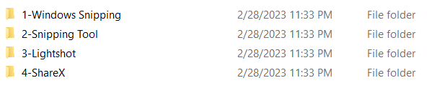

6-Audio Recorder utility
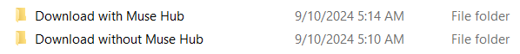

Download with Muse Hub

Download without Muse Hub

7-Screen Recorder utility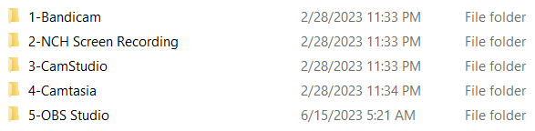

8-Raster graphics editor
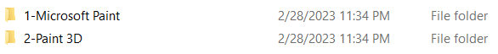

9-PDF
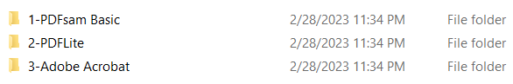

10-Media player
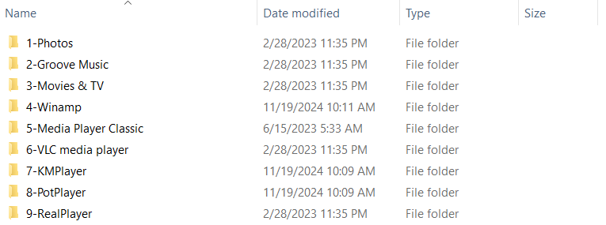
- 1-Photos
- 2-Groove Music
- 3-Movies & TV
- 4-Winamp
- 5-Media Player Classic
- 6-VLC media player
- 7-KMPlayer
- 8-PotPlayer
- 9-RealPlayer

11-File conversion software


12-Tag Editor
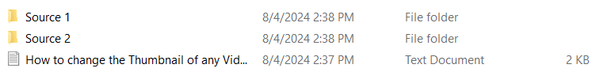

13-Browser
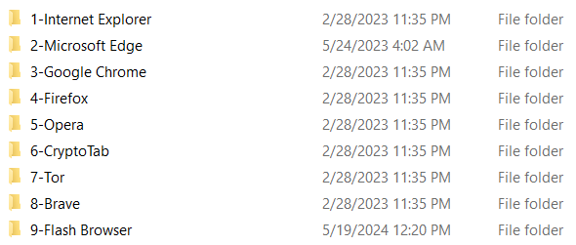

14-Download Manager
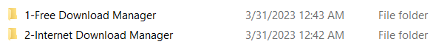

15-Torrent Manager
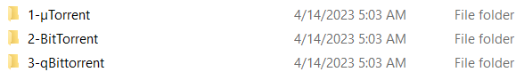

16-Speedtest
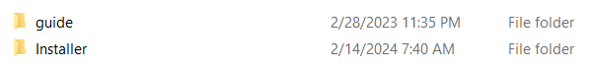

17-File archiver
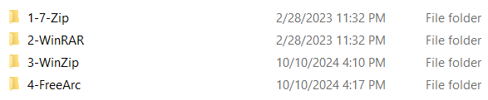

18-PowerShell

19-Virtual machine
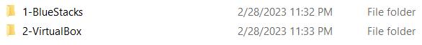

2-Office
It has all Office
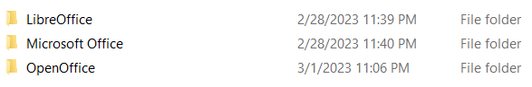

3-3D and graphics Programs
It has all 3D and graphics Programs
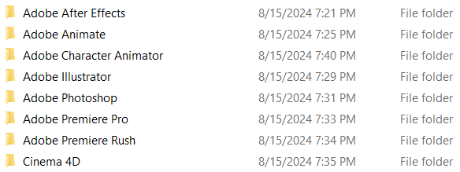

4-Developer Programs
It has all Developer programs
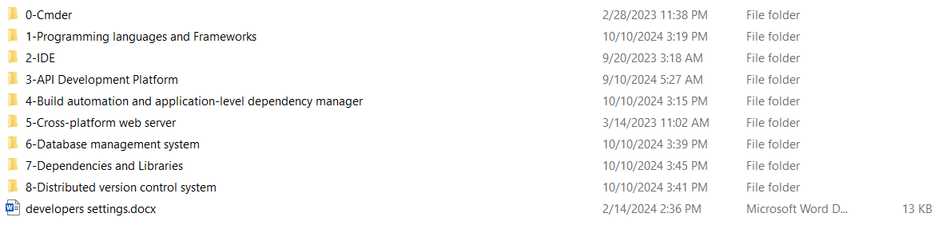

0-cmder

1-Programming languages and Frameworks
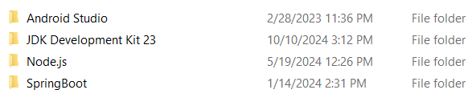

2-IDE
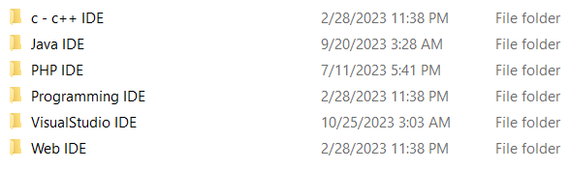

3-API Development Platform
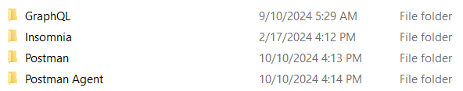

4-Build automation and application-level dependency manager
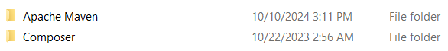

5-Cross-platform web server
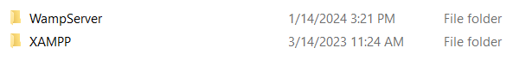

6-Database management system
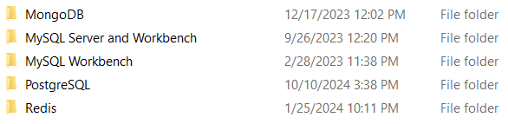

7-Dependencies and Libraries

8-Distributed version control system

5-games Programs
It has all games programs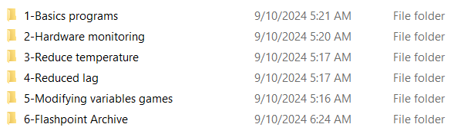

1-Basics programs
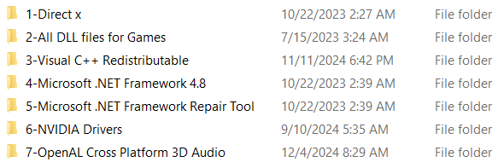

2-hardware monitoring
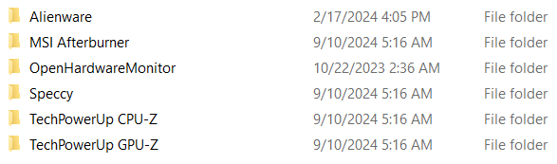

3-Reduce temperature

4-Reduced lag

5-Modifying variables games

6-Flashpoint Archive

6-Operating systems
It has all Operating systems

Others Programs
It has all Others Programs
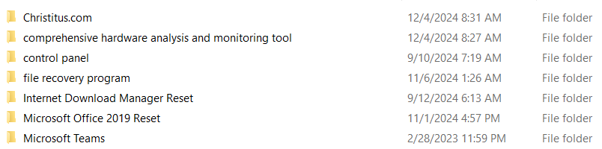

Install Windows Programs
It has all Programs I must install them after install new Window
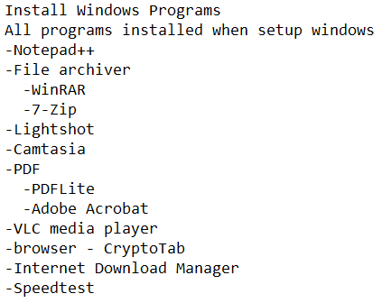

KINGSTON Music & Pictures
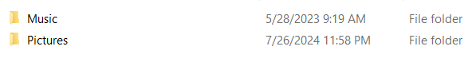
- Music
- Pictures

Music

- 1-Old music
- 2-Modern Music
- 3-Waiting music

1-Old music


1-Neanderthal (40000 BC)
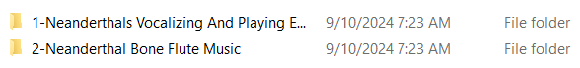

2-Prehistoric (18000 BC)
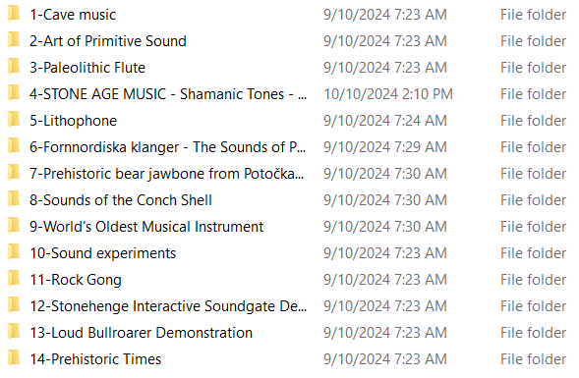

3-old civilizations
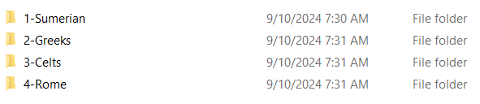

2-Modern Music
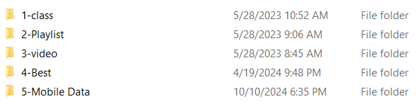

3-Waiting music


Pictures
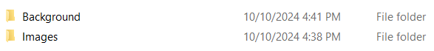

Background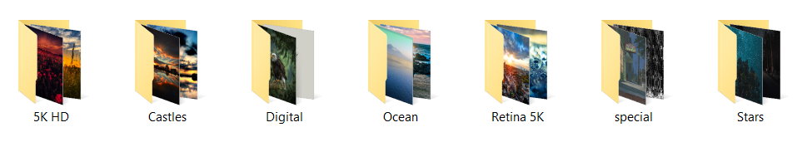

Images
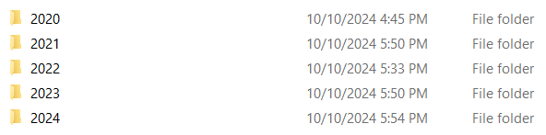

2020
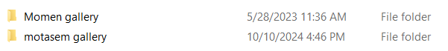

Momen gallery
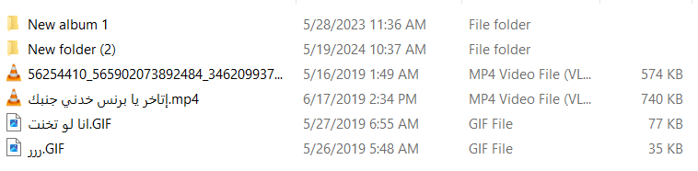

motasem gallery
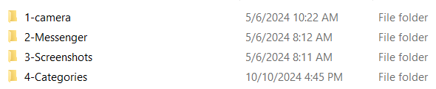

2021
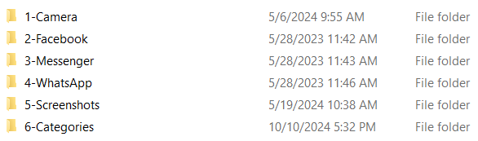

2022

2022 Part1
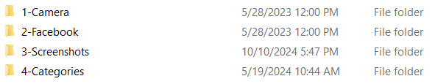

2022 Part2
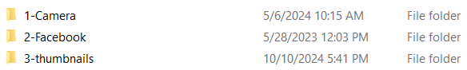

2022 Part3
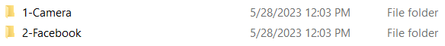

2023

2024
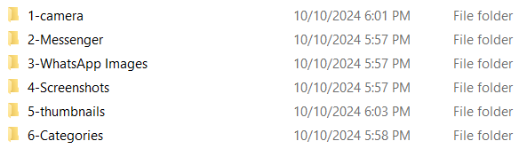

KINGSTON:Movies & videos
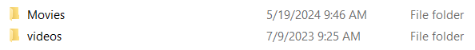

Videos
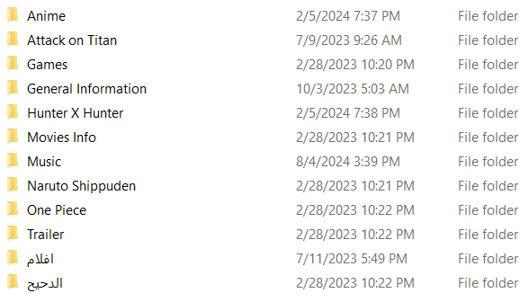

Anime
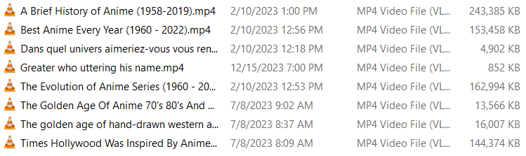

Attack on Titan
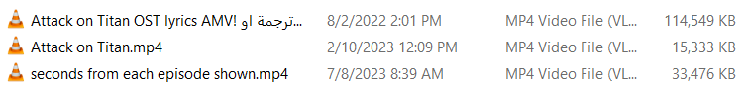

Games
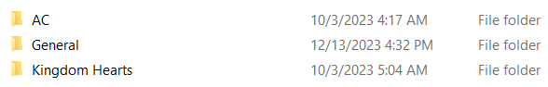

General Information
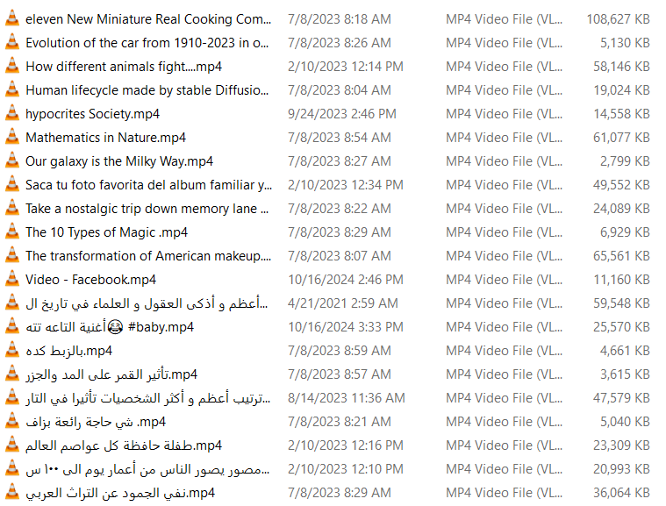

Hunter X Hunter
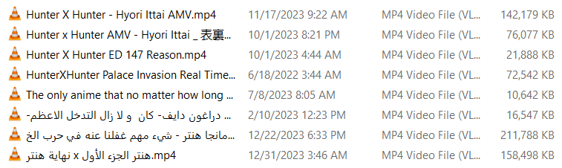

Movies Info
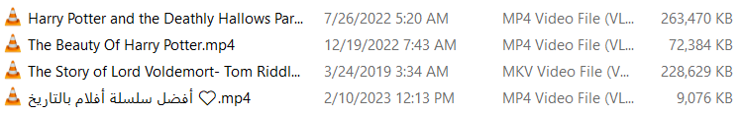

Music
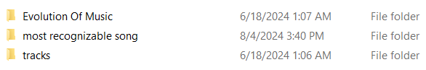

Naruto Shippuden
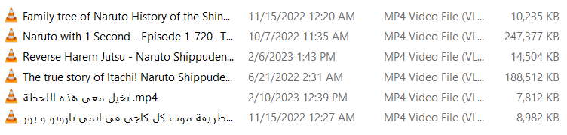

One Piece


Part 1
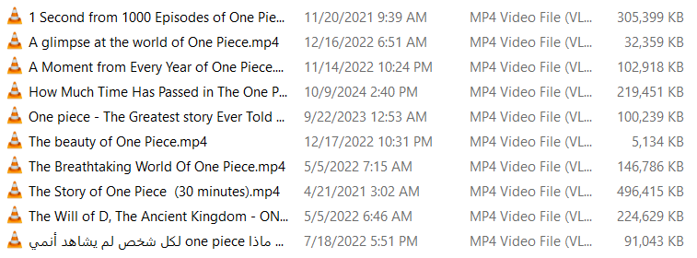

Part 2
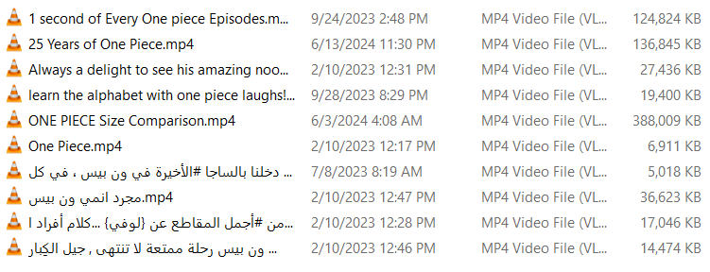

Trailer

افلام
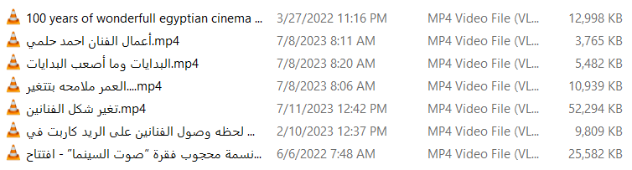

الدحيح
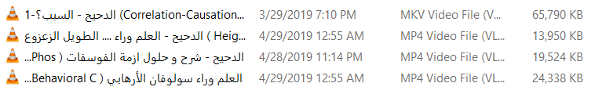

Movies
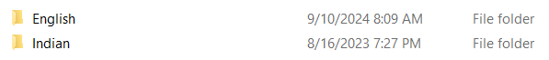

English
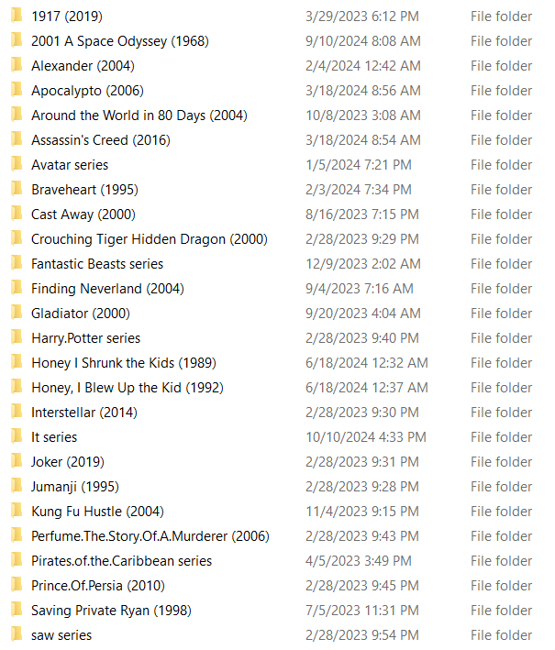
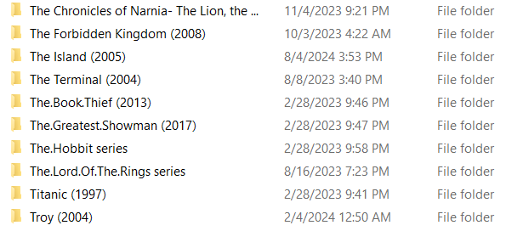

1-Single Movie
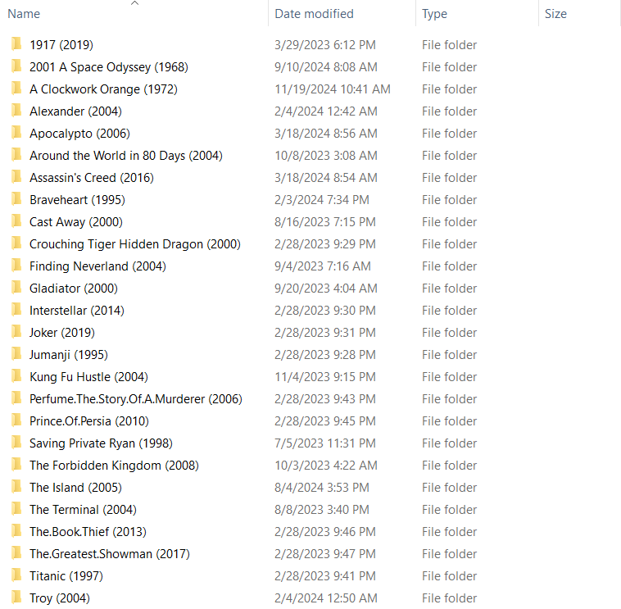

2-Movies Series 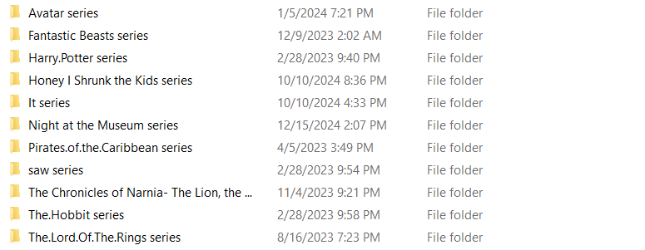

Avatar series

Fantastic Beasts series
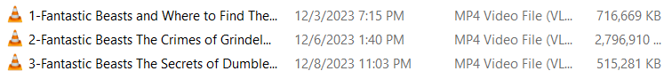

Harry.Potter series
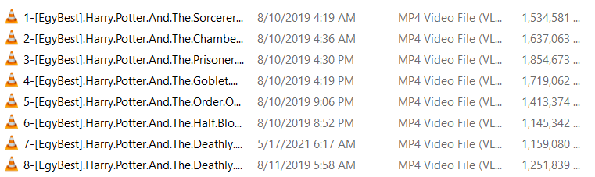

Honey I Shrunk the Kids series
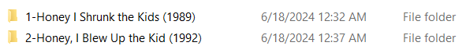

It series
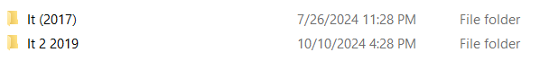

Night at the Museum series
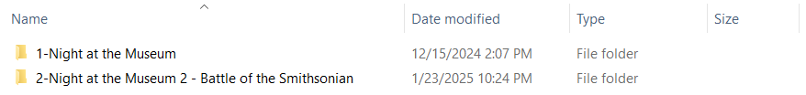

Pirates.of.the.Caribbean series
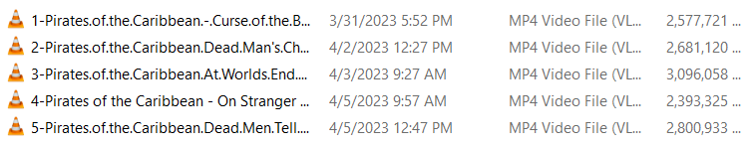

saw series
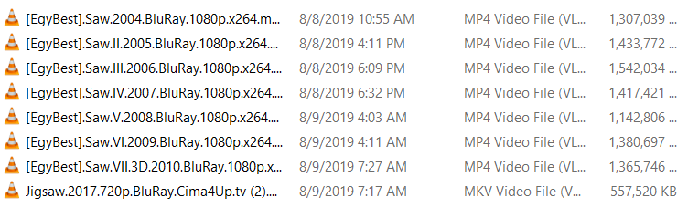

The Chronicles of Narnia- The Lion, the Witch and the Wardrobe (2005)

The.Hobbit series
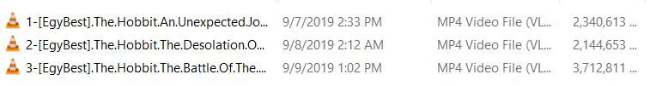

The.Lord.Of.The.Rings series
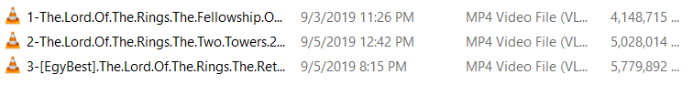

Indian
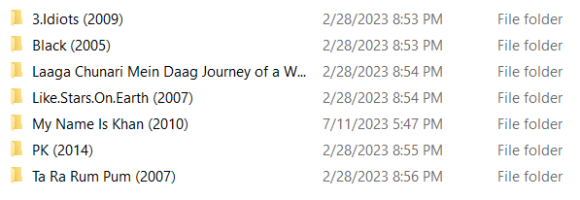

KINGSTON:Movies & videos 2
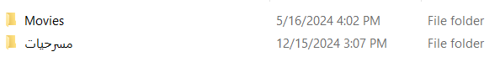

Movies

Arabic
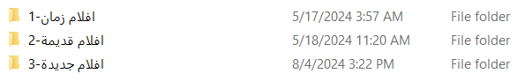

1-افلام زمان
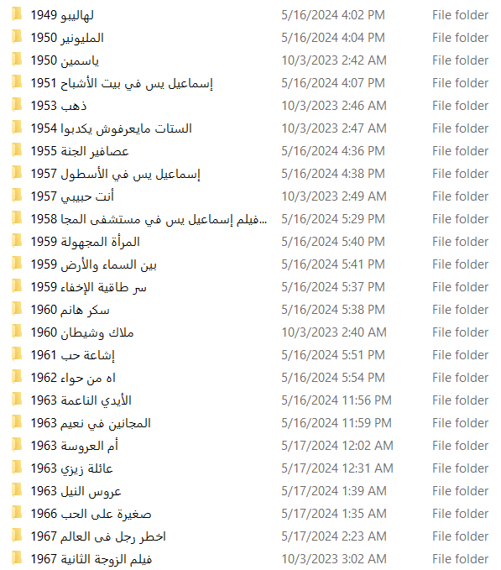
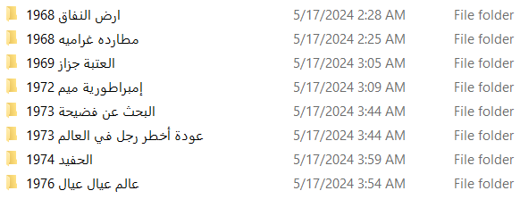

2-افلام قديمة
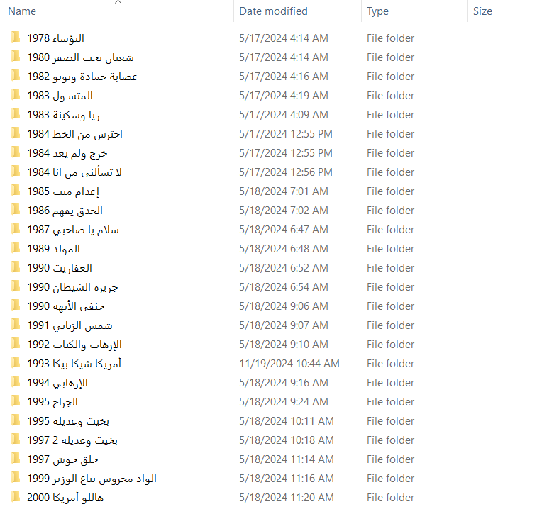

3-افلام جديدة
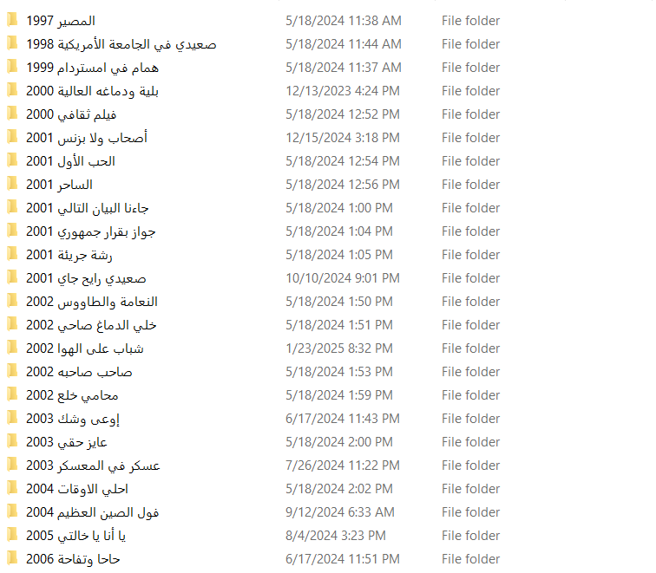

مسرحيات

KINGSTON: Anime Movies
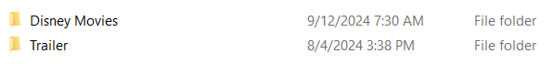

Disney Movies
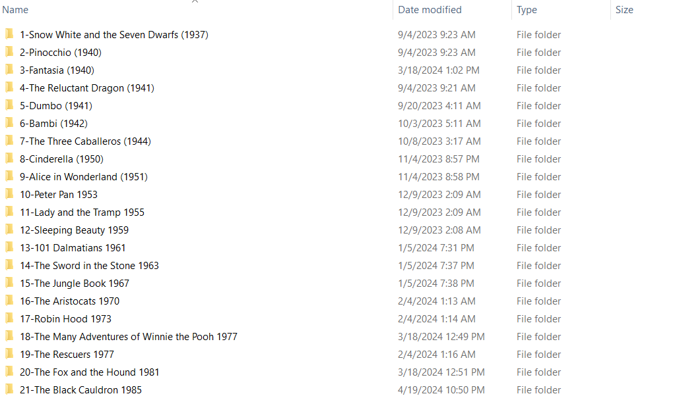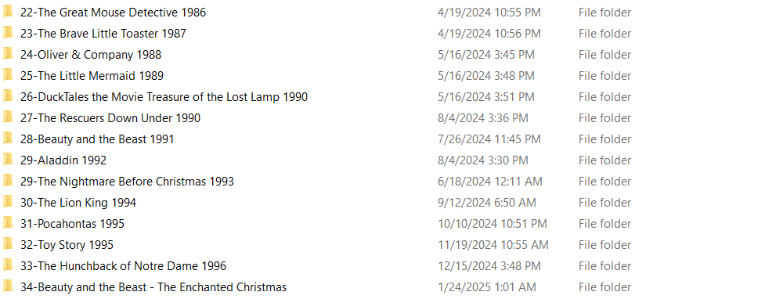

Trailer


Arabic
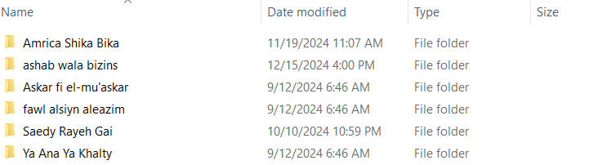

Cartoon
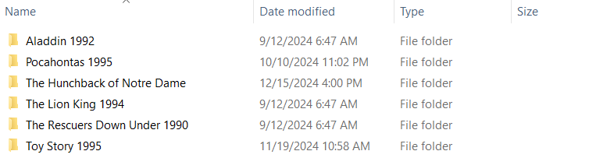

English
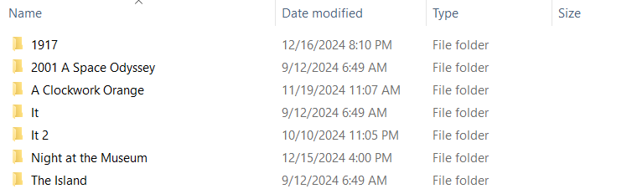

KINGSTON Games
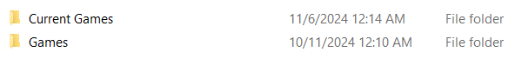
- Current Games
- Games

Current Games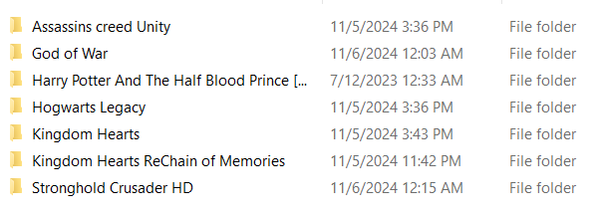
- Assassins creed Unity
- God of War
- Harry Potter And The Half Blood Prince [Spanish][PCDVD][WwW.GamesTorrents.CoM]
- Hogwarts Legacy
- Kingdom Hearts
- Kingdom Hearts ReChain of Memories
- Stronghold Crusader HD

Assassins creed Unity
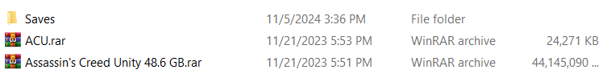

God of War

Harry Potter And The Half Blood Prince [Spanish][PCDVD][WwW.GamesTorrents.CoM] 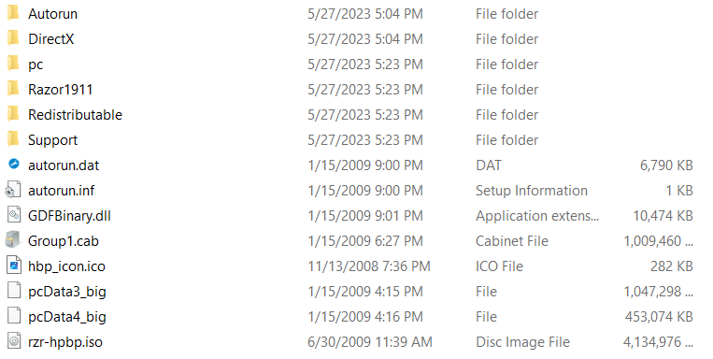

Hogwarts Legacy
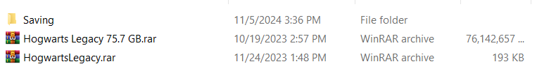

Kingdom Hearts

Kingdom Hearts ReChain of Memories

Stronghold Crusader HD
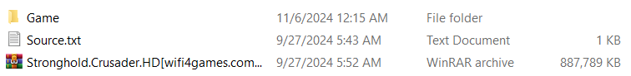

Games
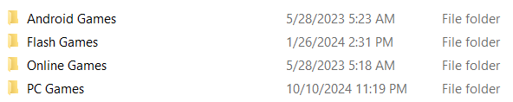

Android Games
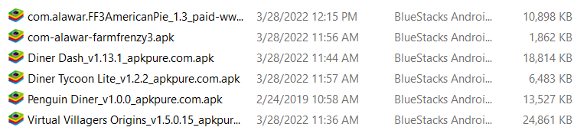

Flash Games

Online Games

PC Games
